XONIX GAME REPORT
TEAM MEMBERS:
DUR E ADAN (24I-3037)
NOAH FARAZ (24I-2585)
INTRODUCTION:
We had to make a complete functional Xonix game with multiple features to be implemented using the SFML library. We designed a dynamic game through multiple stages that started with planning and ended with testing, and enhanced the final product to match the specifications. The joint team effort of Dur-E-Adan and Noah Faraz divided all tasks equally to produce the complete game through each stage of development. The game supports both single-player and two-player modes with multiple levels. Each feature was added according to the rubric provided.
PROJECT WORKFLOW:
The work was divided evenly between both team members, focusing on 1 major aspect of the game in the beginning and then moving onto the smaller easier aspects of the game. Dur-E-Adan was supposed to implement the point system for player 1 in the beginning while Noah worked on the move counter as well as the timer and the geometric patterns that the enemy needed to move in after a while.

TASK DISTRIBUTION:
Dur E Adan started with the reward and scoring system, implemented the logic for calculation of scores, then assigned the rewards where needed, and also calculated the powerups. Noah, on the other hand, was working on enemy movement and speed. He calculated the number of moves, set up the timer, and worked on the zig-zag and circular patterns. Then Adan worked on two-player mode, implemented logic for creation of 2nd player, deaths of players, and usage of powerups through the ‘P’ key from the keyboard. Noah made the menus like starting menu, ending menu, he created levels, scoreboard. Adan worked on file handling , created a text file for storing the previous scores and then sorted them in descending order. Noah added the basic features like easy, hard, medium, continuous levels with different difficulty based on number and speed of enemies. Adan made the function for background music and also changed the color of background from black to slightly blue. Noah made the final report and Adan made the workflow chart on draw.io
GAME FLOW:
When the commands are used on the terminal for the game then the following sequence is followed.

Main Menu:
When the game is loaded up the player is presented with a message “Welcome to Xonix!” and the option of choosing between 1player or 2player modes. These control are purely controlled using number keys for different choices. Number1 is for 1 player and Number 2 is for player 2.
Selection of levels:
When the player chooses the game mode for 1 or 2 player the menu shifts to another screen for choosing game mode.
There are 4 different game modes
- Easy which has 2 enemies
- Medium which has 4 enemies
- Hard which has 6 enemies
- Continuous which spawns 2 more enemies every 20 seconds
These choices are also made using number keys
Game start:
When the game starts there are enemies present based on the difficulty choice and either 1 or 2 players at opposite corners of the grid, with a boundary of built tiles surrounding the grid.
Trail making:
Trail is built when a player enters an empty space on the grid and continuous until the player returned to a filled space on the grid. This was done using different states for each condition.
For example
grid[y][x]==1 means built and grid[y][x]==0 means empty space and when player enters a 0 space we set grid to 2 or 3 to differentiate between the trails of both players.
Scoring & Power ups:
when the user captures tile then 1 point is given, when user captures more than 10 tiles then twice the points are given. When user gains 50 scores, then one powerup is given which can stop the enemies for 3 seconds , if the user wants to use powerup then he can press ‘P’ key. Additional powerups are given after 50 scores with every 30 additional scores.
Collision of Players:
Collisions were also handled using similar logic. As we differentiated the trails for both players it was simple for us to check if a player collided with the other player’s trail.
Grid[y][x]==2 was player 1 trail
Grid[y2][x2]==3 was player 2 trail
Whenever grid[y][x]==3 or [y2][x2]==2 it means it collided with the other player’s trail and that player was killed.
The same was applied if the player collided with their own trail as well. Whenever something like this occurred that player was killed and could not move any longer.
Game Over:
To ensure that game ended when both players died we set up two bool variables player1alive and player2alive and game only ended when both were false.
Ending Scoreboard:
Five highest scores are displayed in descending order.

GAME DEVELOPMENT APPROACH:
In the beginning both team members reviewed the base code and tried to understand how the main functionalities of the given code worked and formulated a plan to effectively work. We commented out certain functions or sections of the base code so we have a better understanding by testing the differences that section makes.
Both of us got started on our specific problems. We had understood from our testing that the grid has 3 states 0,1 or 2 in the beginning. 0 meant that the grid is empty at that place, 1 meant that there were built tiles at that place and 2 meant that player 1 was in the process of building tiles.
Using this logic Noah implemented the move counter. He checked whether the player was on an empty space (0) and previously was on a built tile (1). If this condition was true, then the movecounter variable was supposed to increment. The code for this implementation is as follows.
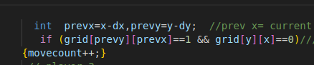
We also had to understand the working of SFML and how to display the different information on different windows and how to draw different objects using its functions. To understand it better we watched a youtube video explaining the basics of SFML drawing functionalities.
The link to the video as well as the name is provided below
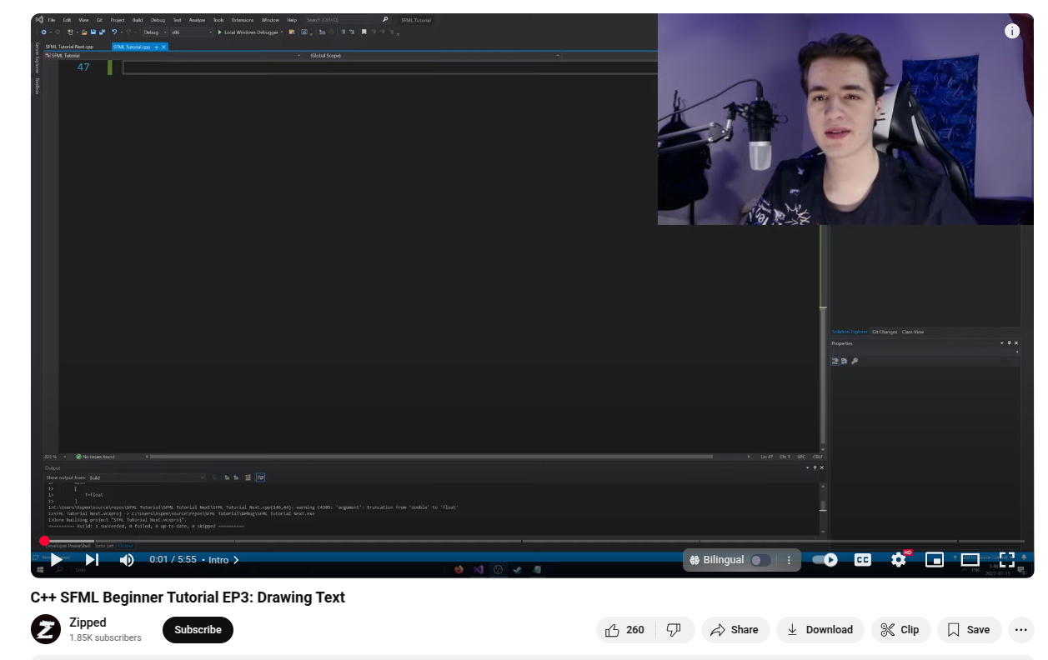https://www.youtube.com/watch?v=Ko8X9Awfrqw
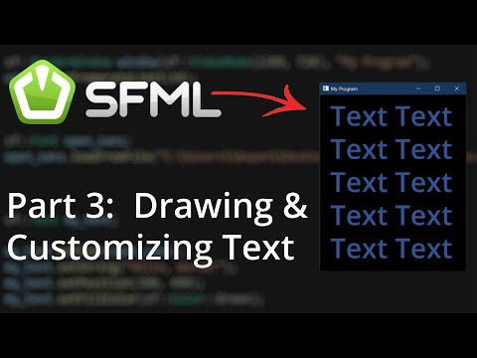

This video allowed us to display different aspects of the game as well as understand some core mechanics of SFML as well such Clock which was used to display the timer and time elapsed for the game.
Focusing on the point system Dur-E-Adan implemented the player 1 score first. She implemented the system to calculate the number of tiles captured by a player and based on that, scores increased by 3. Using different conditional statements.
Noah also worked on displaying and calculating the time taken since the game started. For this he had studied the base code and came across an sfml variable with the name Clock. Upon further research he learnt that this is a built in sfml feature which allows to track time. Using this tracked the total time and also was able to display it on the scoreboard.
Regarding the different screen menus such as player mode, difficulty etc he used the already provided function of RenderWIndow and made neccassary changes to work according to the game requirements. He implemented a simple method of using the number keys to make it easy for user to make decisions based on the type of game they want to play.
For the decisions such as easy,medium,hard or continous Dur-E-Adan implemented bool variables and effectively tracked them to ensure a smooth gaming experience.
Variable enemy speed was a simple task and completed by Noah by increasing the speed by a factor of 2 every 20 seconds using the previously discussed Clock functionality.
Regarding the scoreboard section Adan implemented the working for scoreboard and arranging the score in desending order as well as displayed a message on the scoreboard if a new highscore was registered by the player
CHALLENGES:
We first had no idea about SFML, then we watched videos on YouTube and got the basic knowledge about the structures, objects, and functions of this library. We were confused about implementing logic for trail and its collision, then we used grid-based detection logic and tracked the active cells. We also had to struggle regarding displaying specific things when certain actions took place such as trail of 1 player should not continue when they die and other small functionalities.
LEARNING:
We learnt a lot of things from this project, like rendering screens, making menu pages, SFML objects, functions, and structures. We learnt how to make a multi-featured game. This also allowed to sharpen our logic building and how to approach programming problems. Rather than focusing on the big picture, our approach of dividing up the requirements into smaller more manageable portions proved successful.
CONCLUSION:
This project was a great learning opportunity for both team members, enabling us to collaborate on a task that was not only challenging but also deeply intriguing. Throughout the developmental phase, we were able to strengthen a range of important skills, including effective teamwork, clear and consistent communication, and adopt professional programming practices.

